Brookfield PE Transition Challenges

- Theory Task: Write down the name of 5 muscles found in the body along with their location. As an extension task you can do this for 10 muscles of the body.

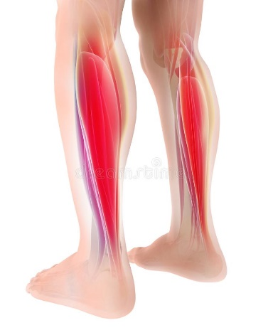
Example: Gastrocnemius (Calf) – Lower leg between knee and ankle.

- Practical Task: Your challenge is to run or jog continuously for 5 minutes. It is really important that you pace yourself during this task so that you select a speed to run at that you are able to maintain. You may need to build your fitness up gradually by doing some short periods of walking during the five minutes.
As an extra challenge, you can choose to run for 8, 10 or even 12 minutes continuously.

